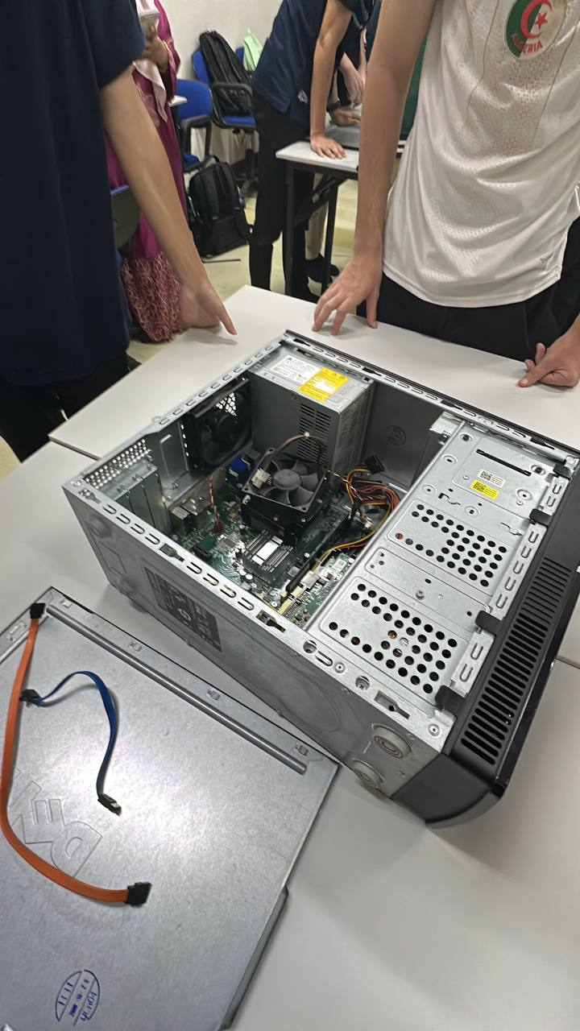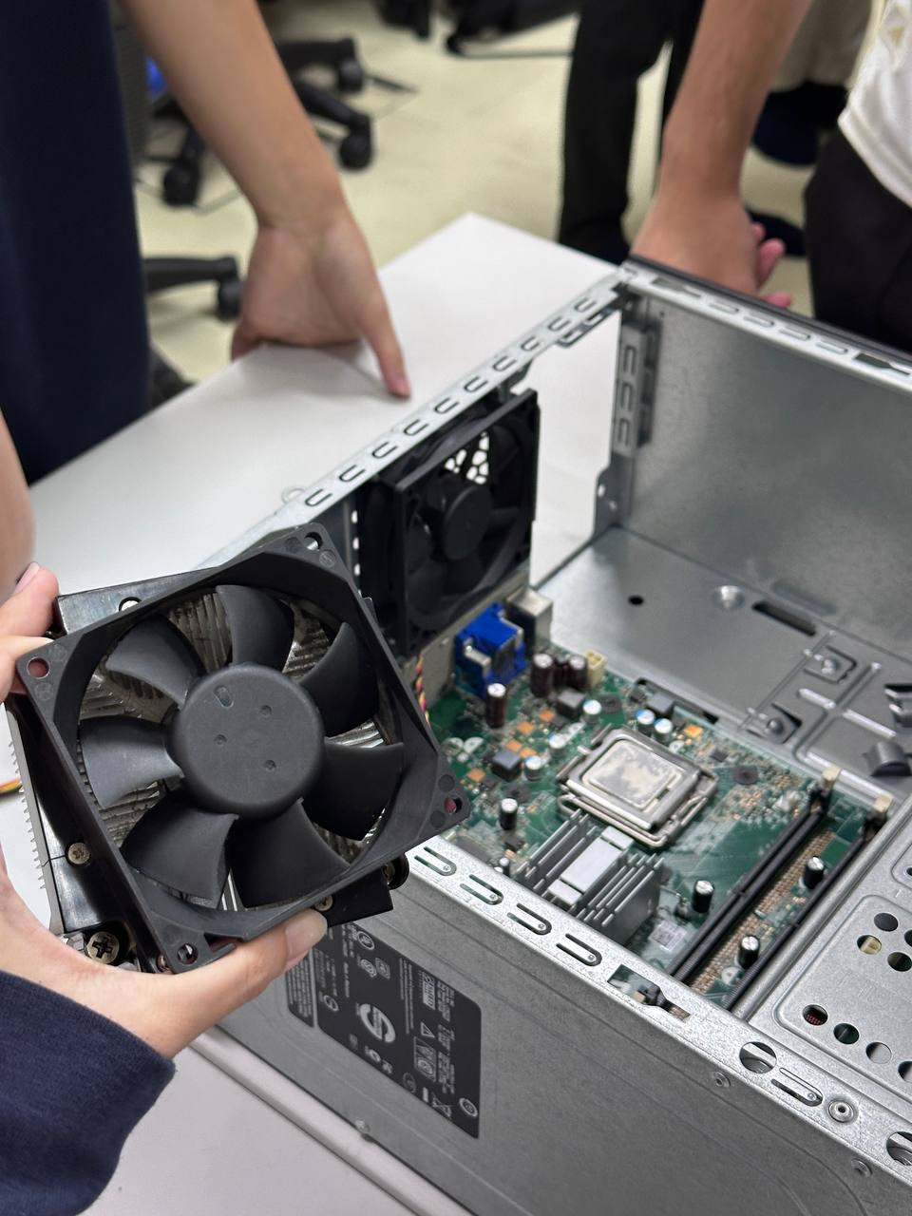
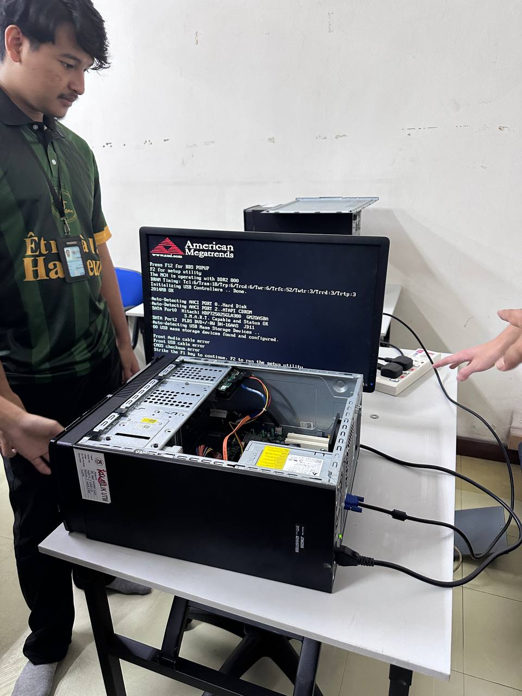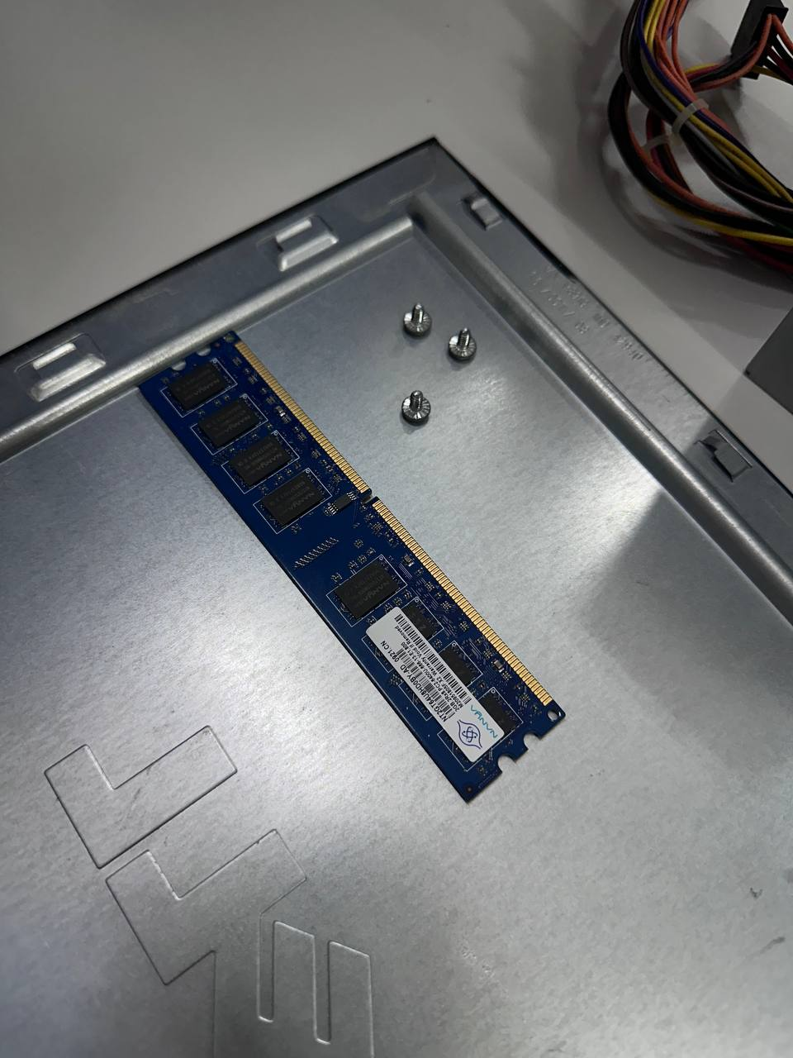

On the 4 November 2026, I attended a PC assemble lab. During this session I was thought of the correct way of assembling and disassembling a PC and the proper way of handling the components of the PC.

Assembling steps:
- Screw in the CPU fan.
- Screw in the hard disk.
- Insert the RAM until it clicks into place.
- Screw in the power supply unit.
- Attach all the cables.
- Close the cover of the PC.

Handling care of the components:
- Do not touch the gold plating of the RAM.
- Ensure cables that have locks are properly locked into place.

